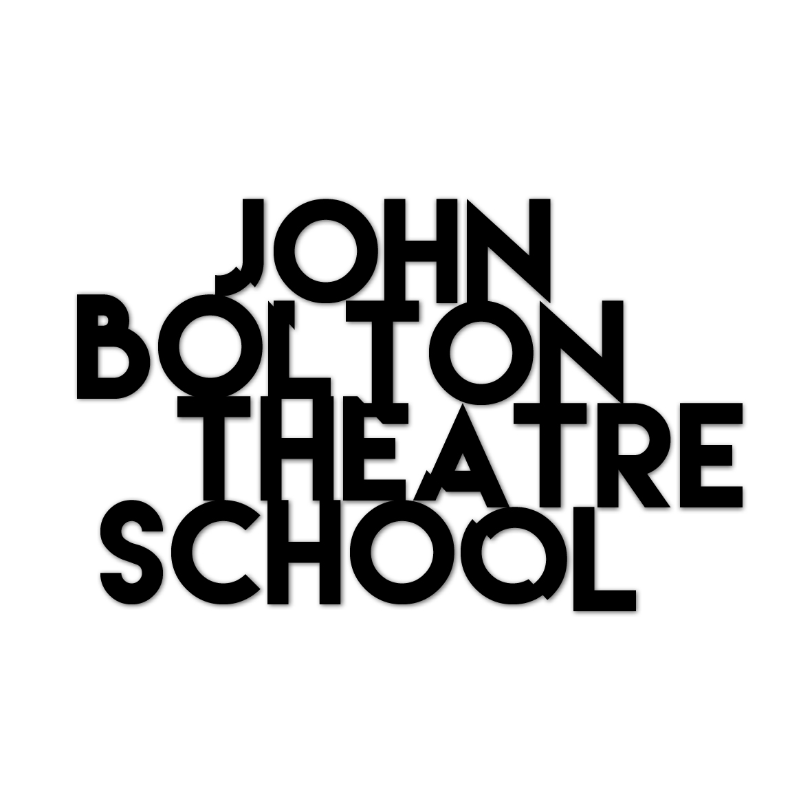
Whangarei, NZ 2017
Stillness to Action:
Three Week Exploration

Application Form

March 20th - April 7th 2017
Monday – Friday 10.00am – 4.00pm

ONEONESIX
116a Bank Street
Whangarei

FULL FEES: $NZ1200 (Due before 10/ 03/17)

EARLY BIRD FEE: $NZ1100 (Due before 01/02/17)

[$200 non-refundable deposit to secure your place ]

Age Range: 18 +
____________________________________________________________________________________________________________

Name:
Address:
Phone: Email: Age:

Write a brief summary of why you want to do this course, what you want to gain from it and what qualities you will bring to it (approx. three paragraphs):

Referee - Please provide the name and number of someone who has worked with you.
Name:
Phone: Email:

Please return with a passport photo or headshot to: info@johnboltontheatre.co.nz
For further questions please call Laurel Devenie: + 64 (0)27 419 9966

