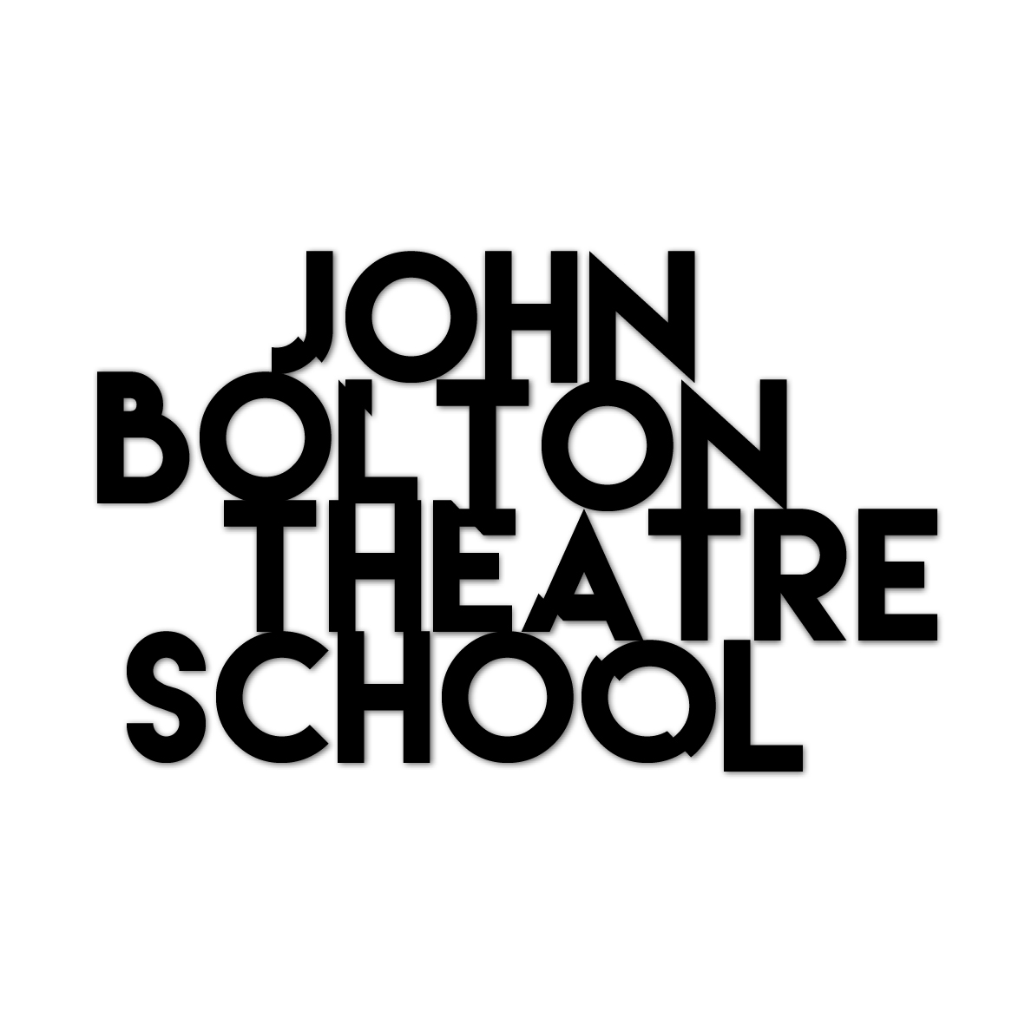
Melbourne 2016

Application Form

August 8th – December 9th, 2016
Monday – Thursday 10:00am – 3:30pm +
Friday – 12pm – 4:00pm

[ Break: 10th – 14th October ]

FULL FEES: $AU4750 / $NZ5000 (Inc. gst)
[ To be paid before 1st June, 2016 ]

or

EARLY BIRD FEE: $AU4500 / $NZ4735 (Inc. gst)
[ If paid before 1st May, 2016 ]

[ $400 non-refundable deposit to secure your place ]
Name:

Address:
Phone: Email: Age:

Write a brief summary of why you want to do this course, what you want to gain from it and what qualities you will bring to it (approx. three paragraphs):

Referee - Please provide the name and number of someone who has worked with you.
Name:
Phone: Email:

Please return, together with a passport size photo or headshot to: laureldevenie@gmail.com
For further questions please call Laurel Devenie: + 64 (0)27 419 9966

